Job Title | Senior Payroll Practitioner | Job Family | TBC
Grade | TBC | Reports to | Payroll Operations and Transformation Manager
Location | Zellis Managed Services, Office Based (Birmingham) | Team Size | Direct – 0

About the role:
In this role you will be an industry expert in payroll legislation and the HCM application. The role will be the third tier of support within the Managed Services Shared Service Centres for both highly complex customer queries, escalations and issues. The role will also support and mentor team member at all levels through hands on side by side coaching and individual training sessions. Enhancing the skill level of each individual and the overall department.

The role will be responsible for understanding the internal and external changing landscape, whether this is legislation, new tooling or developments in customer experience, working closely with industry experts and providing insight back to the Management Team on changes in payroll/HR legislation or process that could impact the service delivery. The role will embed new processes and legislation within the operational teams.

Continual service improvement and customer relationship is at the heart of this role and the expectation is that you will implement efficient and effective working methods with colleagues and customers to drive out inefficiencies, streamline processes and provide overall improvements to the customer experience.

The role will span both the UK, Kochi and ROI geographies ensuring we realise the benefit of knowledge sharing and alignment across the service.

You must support a team culture that provides an outstanding client experience and achieves the Zellis Managed Services vision of SHORE:

- Best Service
- Best Help
- Best Operation
- Best Relationship
- Best Employer

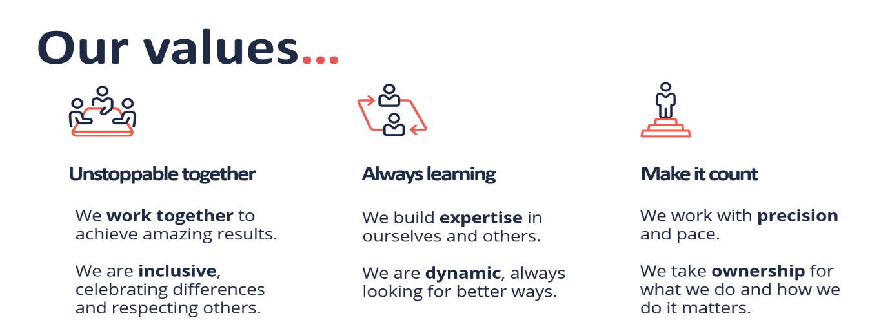

Role Accountabilities and responsibilities:
This role will:
- The 2nd point of escalation for internal and external stakeholders
- Support, coach and mentor team members in UK to independently manage post payroll calls and customer interactions.
- Payroll/HR legislation expert
- Horizon scanner for payroll/HR changes and provide impact assessments on the process
- Expert in the HCM (and associated products) application and set up
- Support, coach and mentor team members in UK and Kochi
- Hand’s on training and development
- Floor walking and knowledge upskilling
- Support with trouble shooting for complex issues and own resolution
- Own updates and regular maintenance for upgrades to include legislation and ad hoc changes
- Innovative and forward thinking regarding streamlining processes for ultimate efficiency
- Work closely with other colleagues in the UK, ROI and Kochi to spread learning and knowledge
Key Responsibilities include:
- Dealing, managing and owning complex, urgent queries or escalations
- Involved and shapes incoming project work to fit with the Managed Service operating model, removing any manual intervention
- Ensure compliance of processes ensuring adherence to the checklist and RACI
- Support with floor walking, one to one training and development for all new starters and team members where new training has been introduced.
- Review operational processes and streamline thorough HCM automation or feed into the transformation programme
- Maintain a training and skills matrix to identify knowledge gaps
- Gathering and validating analytics to support service delivery. This will feed into service packs and will also be used for trend analysis and to inform ‘deep-dives’ into specific activities.
- Incident management and deep dives into incident and provide solutions and recommendations to avoid any future occurrences.
- Quality Assurance for case management and telephony call performance
- Support year end activities
Essential Skills:
- Positive attitude and energy, with a passion for building relationships
- Coaching experience and training team members
- Payroll legislation knowledge, but also sector specific payroll insight
- Problem solving and solution provision
- HCM configuration and optimisation
- Appropriate mix of skills & experience including technical aptitude and in-depth payroll expertise
- Experience of addressing IT related requirements, incidents and activities
- Strong inter-personal and communication skills to liaise effectively with Zellis team members (including sourcing advice and insights from broader product and IT teams) and clients (including inputting effectively to account review meetings)
- A desire to develop and the ability to self-manage work schedules and competing commitments

People Leadership / Team Leadership:
About You:
- 5+ years in Payroll Services
- CIPP qualified or can demonstrate the experience
- Coaching and learning experience
- Ability to multitask, deal with complexity and conflicting priorities/projects/ deals at the same time
- Be able to think both strategically and tactically

About Zellis
Zellis is the leading provider of payroll and HR solutions for the UK and Ireland.
Together with Benefex and Moorepay, we form the Zellis Group, serving a vast array of companies across every vertical and industry.
Our purpose is to make people feel appreciated for the work they do – through precision, choice, and magic.
Our history
We have over 50 years of heritage and industry experience – and we’ve been ahead of the curve throughout.
More than half a century ago, we were founded as Peterborough Data Processing. Quite a lot has changed since then – not least our name.
We were acquired by Northgate, becoming NorthgateArinso in 2007 and NGA Human Resources UK and Ireland in 2014, where we were joined by Moorepay. In 2018, the UK and Ireland division was sold to Bain Capital and now we operate as a standalone company.
After acquiring Benefex, we’re now even better equipped to serve the complex needs of our customers.
Our vision
Our vision is to be the clear leader in pay, reward, analytics, and people experiences. There’s nothing more important to us than building trusting and beneficial relationships with our customers, using our size, scale, and breadth of experience to offer tailored solutions that precisely meet their business needs.
We design solutions that keep our customers ahead of change as they navigate the regulatory complexity and workforce uncertainty which exists in today’s business landscape. At the heart of everything we do are our highly qualified payroll and HR experts, who are committed to delivering first-class customer service at all times.
We’re proud of our culture
At Zellis we work hard to create a culture where people want to join, belong to, and be part of a progressive organisation.
We’re committed to recruiting and retaining a diverse and inclusive workforce that is representative of the customers we serve and the communities we operate in.
Our values, which were defined with input from all of our 2,000 colleagues, are not empty words on a poster. They reflect who we are, and how we operate as a business:
Unstoppable together.
We work together to achieve amazing results.
We are inclusive, celebrating differences and respecting others.
Always learning.
We build expertise in ourselves and others.
We are dynamic always looking for better ways.
Make it count.
We work with precision and pace.
We take ownership for what we do and how we do it matters.

